ADMIN

* Firstly, to get into the admin panel, first you must click on the login button at the top right of the navigation bar

[Login Testing]

* If the trader provides valid email/username or password then the admin is redirected to admin panel

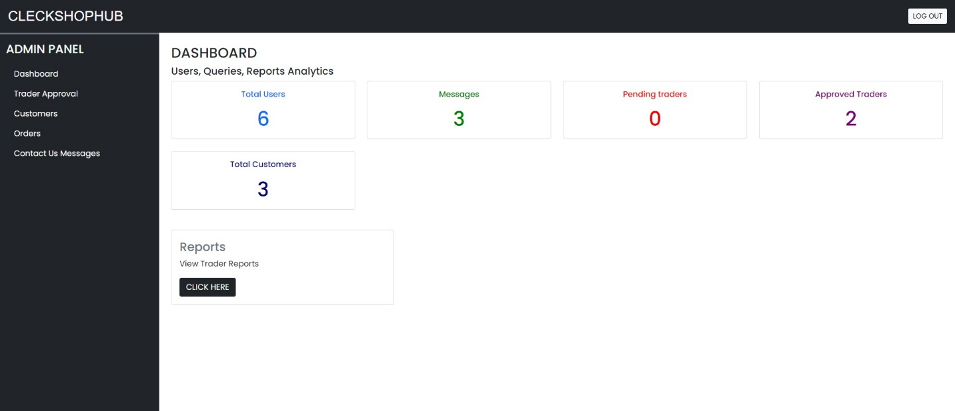

* If the admin provides an invalid email/username or password then a red error message is shown displaying the email/username or password is invalid

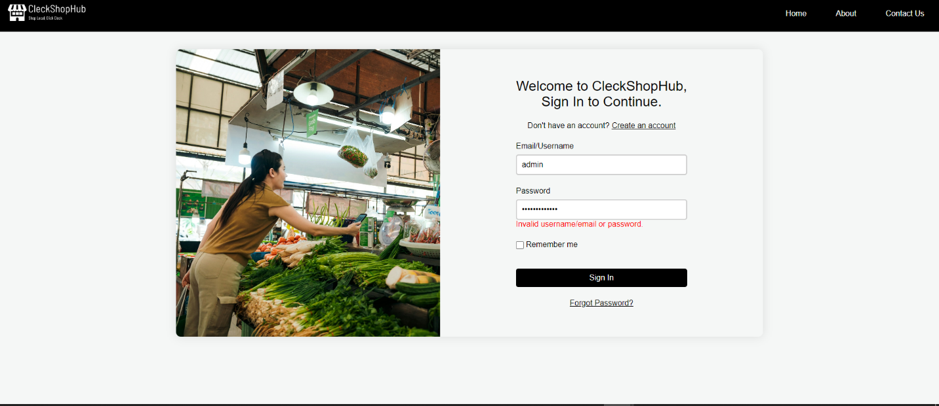

* If the admin ticks the remember me button then the admin is not required to enter the username or email details again

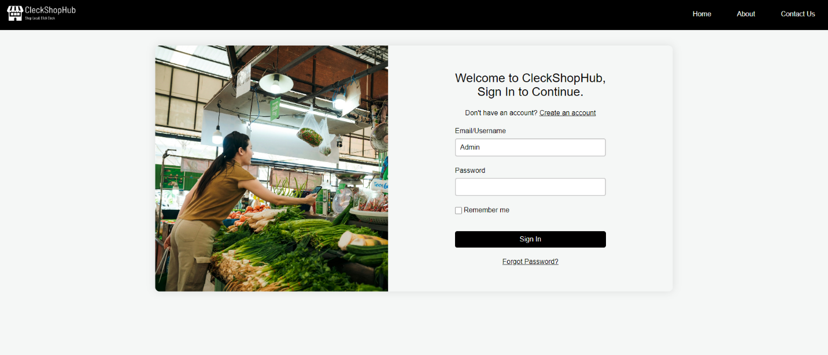

* If the admin clicks Sign In without providing any details then a message is displayed prompting the admin to fill in the empty input fields

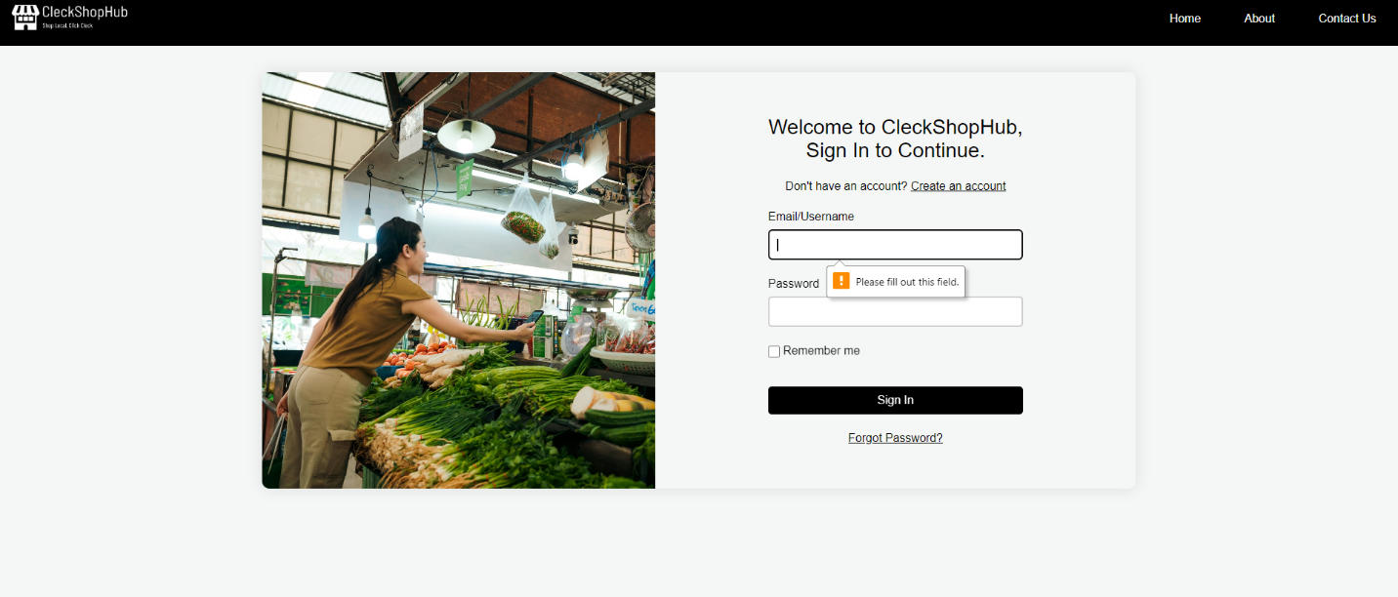

* If the admin clicks on forgot password link then the admin can change their password after providing their email address then receiving an OTP code for validation, then finally the admin is able to successfully change the password

[Dashboard Testing]

* If the admin clicks on the “Click Here” button in Report section then the admin is redirected to the Oracle Apex Application

[Trader Management Testing]

* If the admin clicks on the green “approve” button in the Pending Traders section then the trader is shifted to Approved Traders section

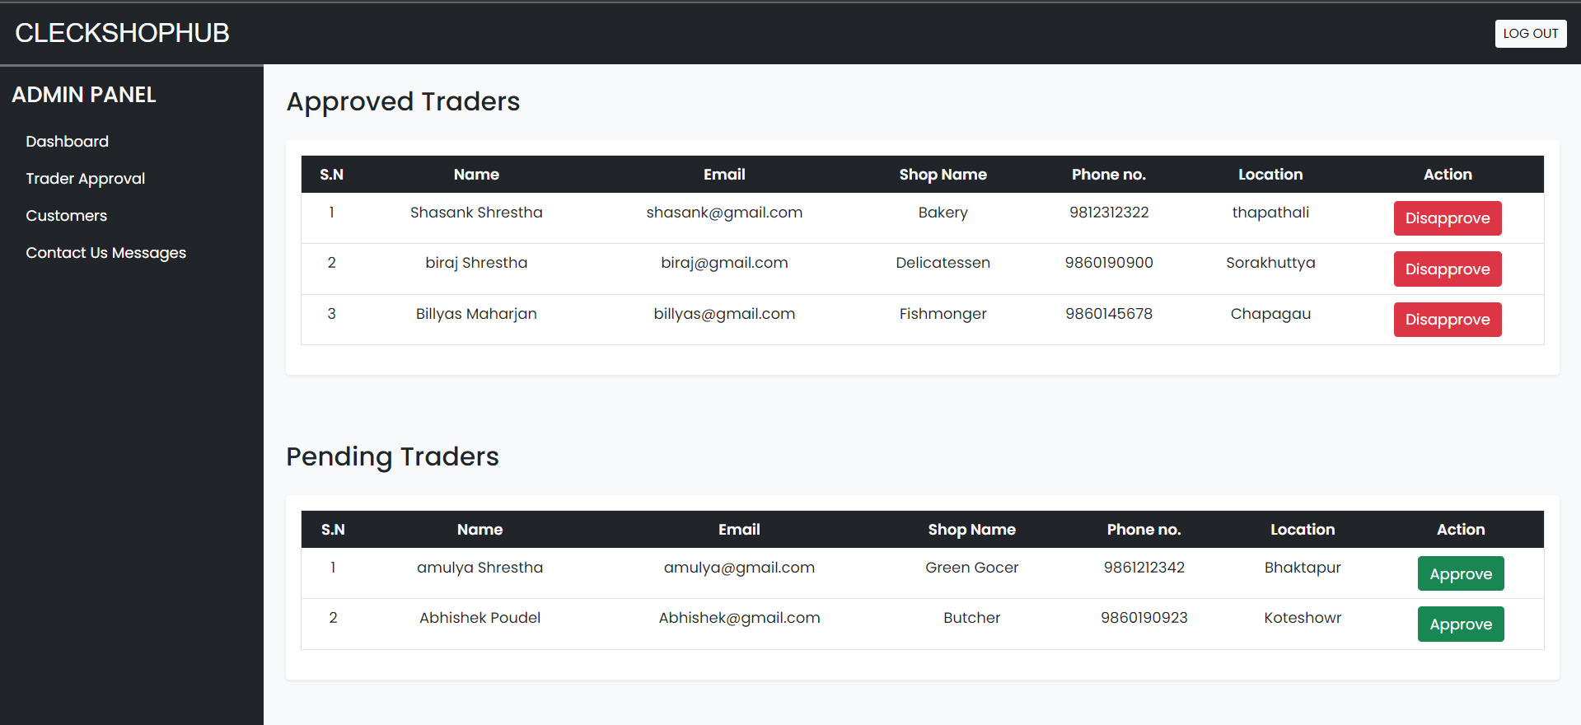

* If the admin clicks on the red “disapprove” button in the Pending Traders section then the trader is disapproved.

[Customer Management Testing]

* If the admin clicks on the “delete” button then the admin can remove the customer with all their associated records

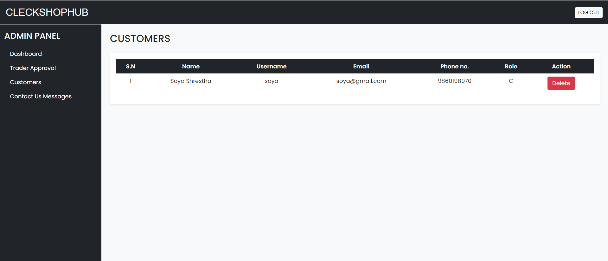

* If the admin clicks on the “delete” button in the user queries tab then the user query or message is removed

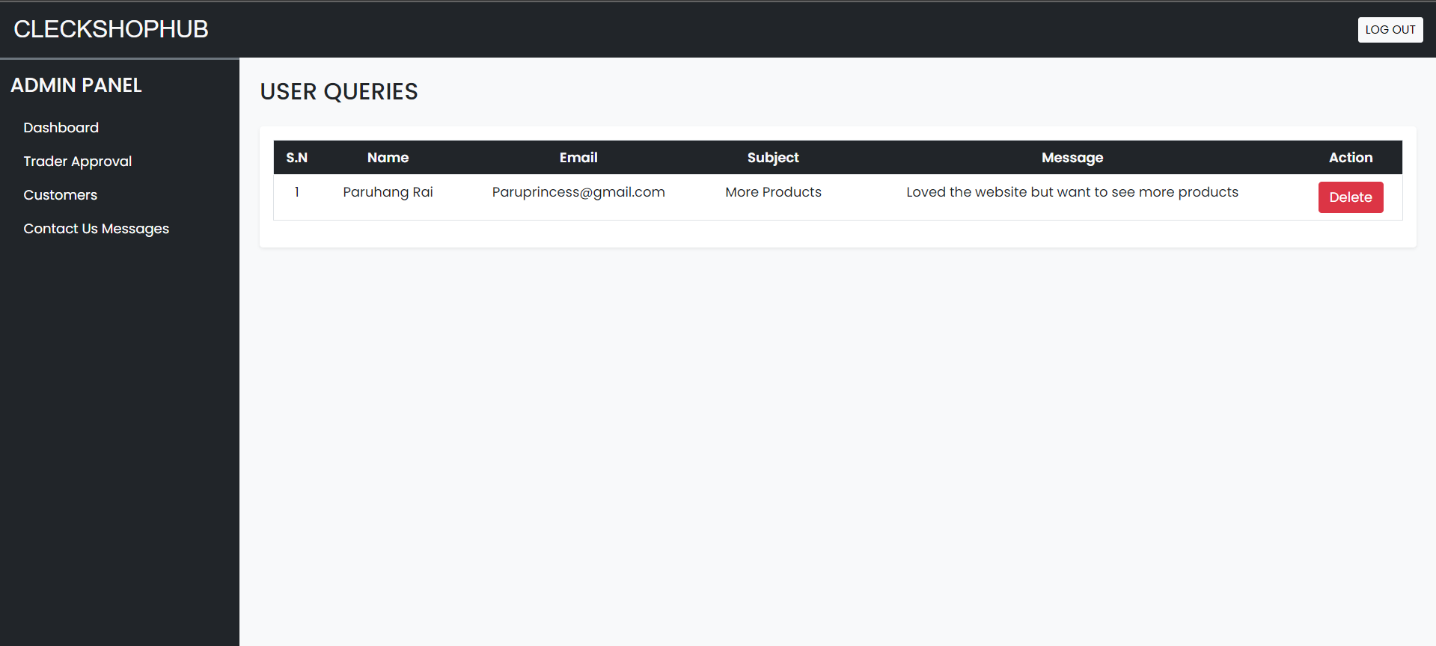

[Logout Testing]

* If the admin clicks on the logout button at top right of the navigation bar then the admin is redirected to homepage